
Brief report: PON workshop 15/3/23

Recording & evaluating personal outcomes

Context

Over the past year, PON members have consistently identified recording (and evaluation) of personal outcomes as a priority theme to explore in the network. For 2023, we have therefore made recording our focus for at least the next two workshops. The first of these was held in the Apex Hotel, Waterloo Place, Edinburgh on 21/3/23. 52 delegates from diverse roles across health, social care and children’s services listened to stimulating presentations and took part in table discussions.

Later in the year we intend to produce a resource with content from the series of workshops, evaluation information and a range of useful links. This is a brief summary of workshop one.

Content of the Workshop

We had four excellent presentations from diverse sources. This workshop leaned towards evaluation and policy, with only one of four presentations on recording practice. The balance will change in the second workshop which will be practice focused (details at end).

Hopes for the Day

We asked participants to note down and discuss in pairs what they hoped to get out of the workshop. Responses were diverse. Some comments, whilst reflecting different roles, were typical of aspirations which are commonly expressed in PON workshops:

- Anything useful and beneficial for the people who use our services
- Hear about great things happening in local areas
- Find a way to support team to understand outcomes beyond activities
- Networking
- Be re-inspired
- To make contact with practitioners who can support my policy role
- Networking opportunities
Comments also in many cases, reflected existing knowledge and skills on this topic, which people wanted to build on. A few examples follow:

- Difference between achieving a goal and an outcome and documenting this
- How to build personal outcomes into mandated care and support e.g., criminal justice, LD, children, and families
- How PON work sits within emerging policy. Keen to hear more about GIRFE in particular, and use learning to inform strategic/operational plans
- How are we moving away from performance-based culture
- Relationship between H&SC professionals in meeting the outcomes of people with more complex care needs
- Gap between commissioning measures and meaningful outcome measures
- Changing the need to talk two languages – deficit and strength based
Presentations

Below we include one slide from each presentation as an illustration of content. The full presentations can be viewed here.

Evaluating outcomes, Ailsa Cook, Matter of Focus

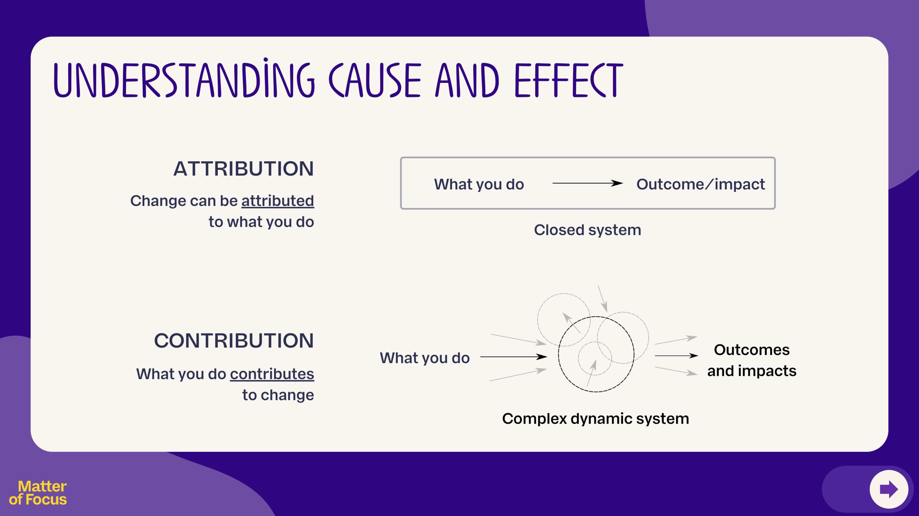

GIRFE, Grant Laidlaw, Scottish Government

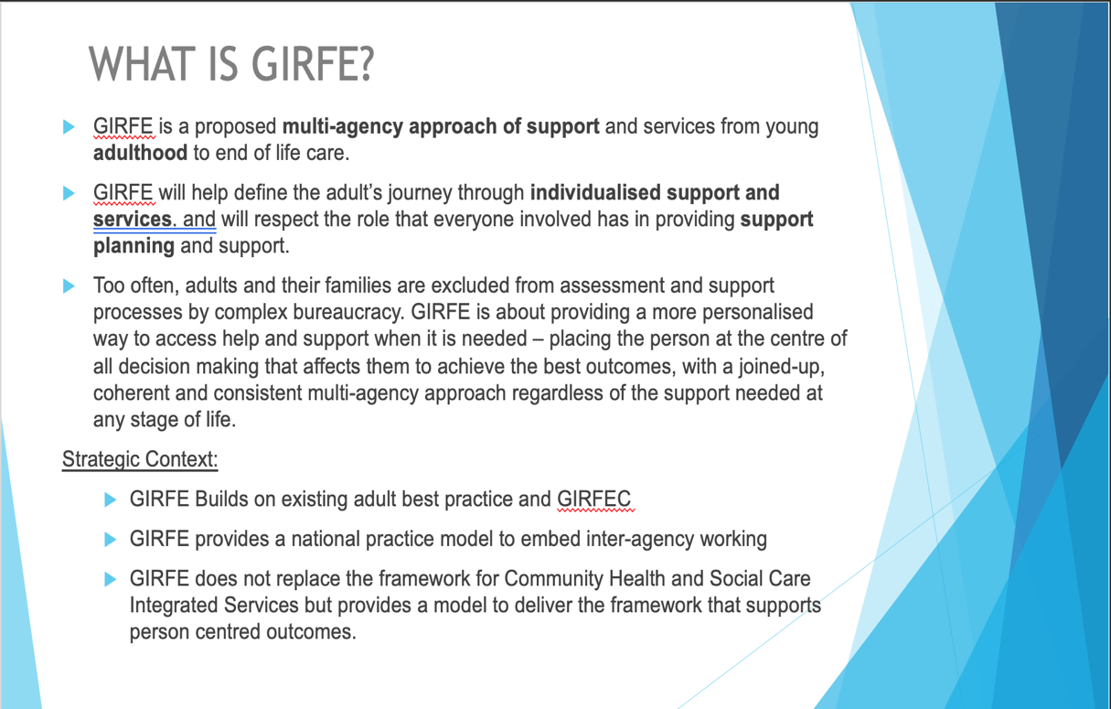

Person-centred measures, Shaun Maher and Suzi McPherson, Scottish Government

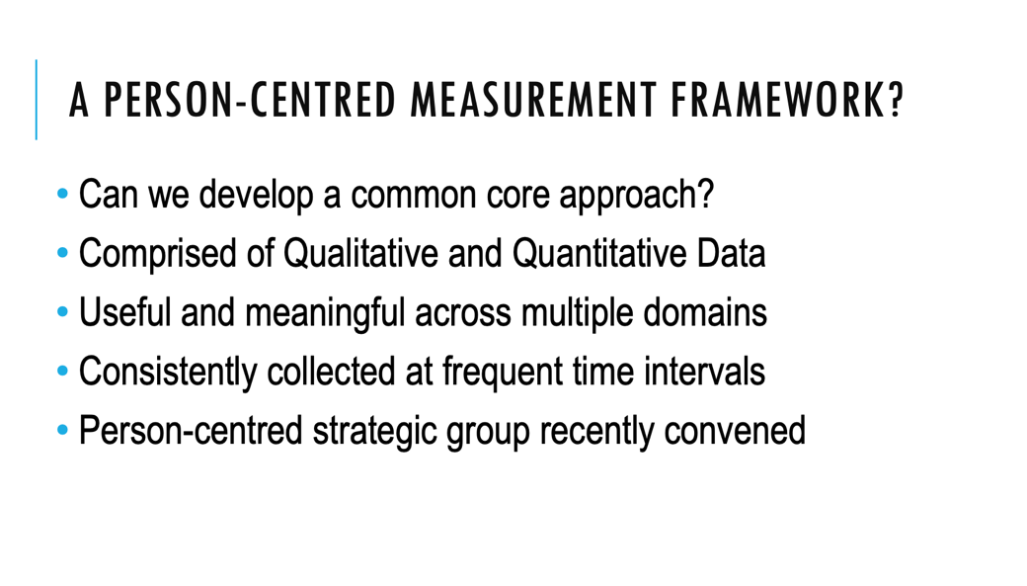

Recording practice, Ellen Daly, Iriss

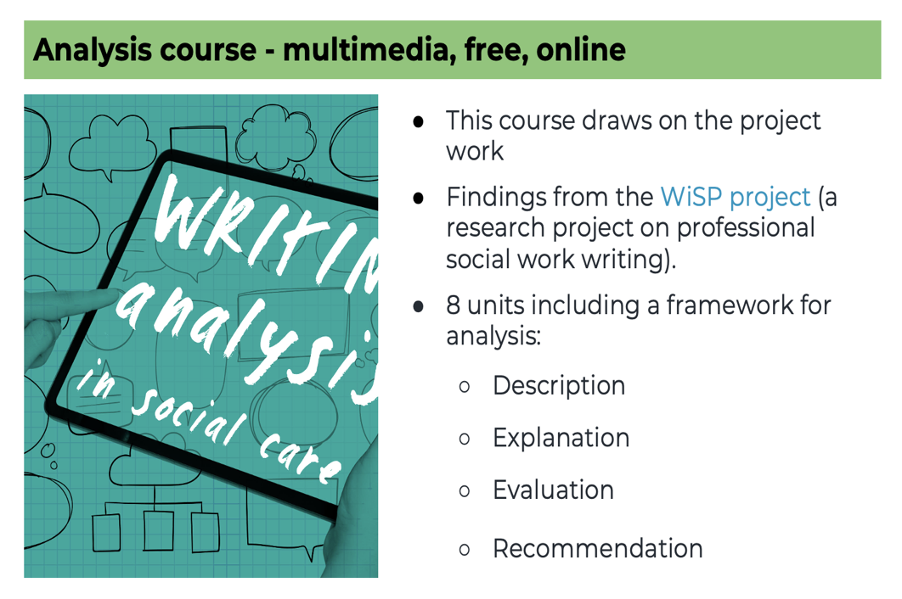

Table discussions

There were three themes for table discussions and we gathered a wealth of data from them. We will report more on this later this year. Here we include a few example from each theme,

What helps your own practice and what gets in the way

- How do we support staff to be confident learners? Lessen the fear factor of proving and scrutiny – build reflection skills – changing the culture of the system
- Questions we ask shape the story we hear
- People don’t understand how the data they provide is used in wider context to make changes
- I feel very aligned to this because if not working for the person, what is the point
- Important to talk about what’s working well - talking about challenges is easier. Discussion is important to surface the strengths.
What support is needed at national level to support a focus on outcomes

- A mandatory requirement to report on what matters to people and the differences we are making
- Recognition that needs time to change systems and culture – often expectation is that it can/should happen quickly
- Embedding focus on what matters, strengths (good conversations) into training and education of all professionals
- Can we align H&SC standards with Excellence in Care/GIRFE
- Recognition that all staff need ongoing development opportunities to have these conversations
- Is this something else we have to evidence?

A lot of points in this section repeated a few key themes:

- All of these initiatives must be underpinned by lived experience including people whose voices are not usually included
- GIRFE and any measures needs to align with what else is already going on, including SDS, personal outcomes, health and care standards, and the evidence base needs to be shown

How we make recording meaningful

- Writing the record with the person
- Changing value given to recording – increasing this
- Must support staff on as ongoing basis – with conversations and recording
- How to write in transparency? Can we have workshops on how to record? Scenarios and examples
- Record as though the person who this is about – may read this
- Model good recording in supervision by what’s recorded
- Analysis needs to tell the story of the discussion and outcomes - takes time and effort - skills developed over years. Need good (and bad) examples of recording.
- Idea for next event: Examples of what best practice could look like - to help benchmark

Feedback

- I finally understand GIRFE
- Contribution not attribution - key in changing our thinking
- Heard some thoughts on trauma and how I should reflect on my own work
- Did not know about policy developments e.g., GIRFE. Person-centred measurement, good to learn about work at early stage
- Really interested in finding out more about matter of focus and Iriss recording training
- Enthused by size of network, momentum around this way of working
- I felt an uplift in my energy and interest – given the good conversations and insights
- Camaraderie
For more information on the PON, the presentations and a section on recording personal outcomes (with relevant resources) please look here

Our next event on recording practice is online on 14th June. To join the network, please email PON@nes.scot.nhs.uk

