

Brief report on PON workshop on leadership, wellbeing and outcomes
Held 26.10.22 at the Studio in Glasgow

Presentations

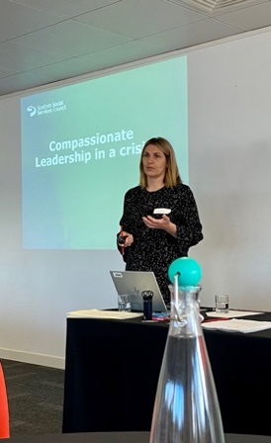
Julie Gracie from SSSC on compassionate leadership through crisis

Key message included that self-care is self-leadership. Paying attention to our own wellbeing is not an additional ‘nice to do’ activity but is an essential act of leadership. Julie hit a note for everyone in the room when she said: “We are all doing the best we can with what we have and know.” For more on compassionate leadership Compassionate-Leadership-Booklet.pdf (roffeypark.ac.uk)

Julie is keen to stay in touch with the PON and to come back and share more exercises and materials with us

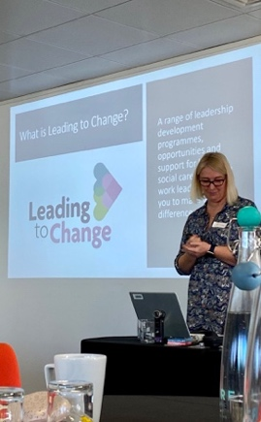
Fiona Dee from NES, introducing Leading to Change

Fiona’s input was presented as the start of a conversation with the PON. She shared information about the Leading to Change which offers a range of leadership development programmes, opportunities and support for health, social care and social work leaders to help staff to make a difference.

Fiona shared information about a coaching opportunity available to all staff – please see details below

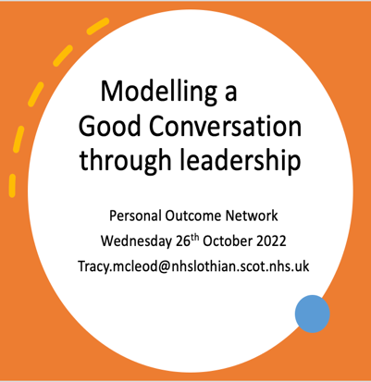
Tracy McLeod, Midlothian HSCP- Modelling good conversations and leadership

Over several years Tracy has contributed to the development of the Midway approach which promotes outcome focused and strengths-based practice in Midlothian HSCP. More recently, attention has turned to promoting that type of conversation at all levels within the organisation, in response to feedback from staff. Tracy’s slides are on our website (see link at end)
Wellbeing

One of our speakers from unfortunately unable to attend due to ill health. However, we took the time to consider three wellbeing questions at our tables

* What is it that is important for me to do every day to keep my sense of wellbeing?
* What are the triggers and early warning signs that tell me that my wellbeing may be slipping?
* What actions do I need to take when I notice this?

This session provoked a lot of thoughtful discussion and exchange of practical suggestions.

Coaching opportunity

Coaching for wellbeing was initially creted to support colleagues facing challenges resulting from the pandemic. As the pressures continue, the offer is still open to all colleagues in Health, Social Care, and Social Work in Scotland to access this coaching support.
- How are you feeling now? Is it time for you to focus on your own health and wellbeing?
- Has your confidence in delivering your role been impacted due to pressures at work or in your private life?
- Are you a leader who wants to support your colleagues or team members?
If the answer to any one of these is “Yes”, you may benefit from 2 hours of free coaching, designed to support all Health, Social care, and Social Work colleagues across Scotland.
https://wellbeinghub.scot/resource/coaching-for-wellbeing-a-digital-coaching-service-for-all-health-and-social-care-staff/
Invitation to check-in event from Leading to Change
Dec 6 Online | 10:30 am - 11:30 am
Leading to Change have issued an invitation to their check in event as follows:
This is a chance for us to welcome you into a conversation where you can find out what’s going on in Leading to Change and to share what’s going on for you. This session will:
- share more about what’s available including details of our current offers,
- explore how this might connect with the work you do locally,
- ask for your thoughts on the leadership challenges you face,
- ask what leadership development offers you feel would support you in future.
There will be an opportunity for a Q&A session with the delivery team as we know this is important to you. https://leadingtochange.scot/our-events/l2c-check-in-event/
Feedback from delegates (examples)

Something I have learned

Reflect and write down your thoughts – redefine your boundaries to avoid overload!

There are amazing resources available free to share

Hearing that we are all trying to do our best is comforting and reassuring

I have learnt the importance of modelling the behaviour that we want to embed at all times

Self-care is self-leadership

We need a revolution with flags

Something I felt or experienced

So much to learn and so many to learn from – excited – nurtured

It’s ok to make mistakes

My self care is key to being able to promote and support peers

I don’t promise to fix someone’s problems. But, I promise they won’t need to fix them alone

Venue has been great. Had lots of self-care needs met I didn’t realise I needed

Something I will take away

Importance of whole system approaches

The importance of being and staying human

My optimistic tank refilled

Having permission today to reflect and be proud of how I have demonstrated compassion

There is a lot of personal outcomes work going on in other areas too

Something that could have been done better

Too much sugar/more fruit please but a good healthy lunch

Felt rushed – input from speakers could have had more time

What next and resources

Look out for information about our next events to be announced shortly. These are likely to include an online event in the new year and a face-to-face event early in Spring.

Meantime we continue to working with colleagues in policy and practice to keep a focus on outcomes and will report more on that shortly

https://personaloutcomes.network/

