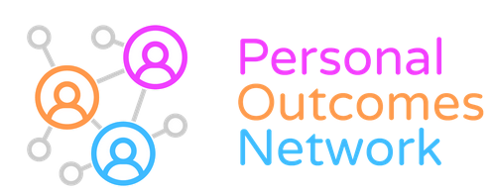
Personal Outcomes Network Planning session: summary report

22/6/22, Golden Jubilee Conference Hotel, Clydebank

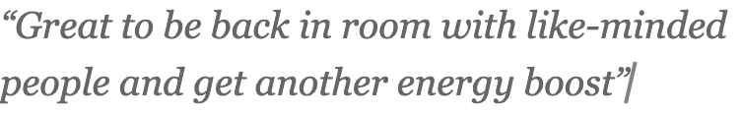
About the session
Our first face-to-face meeting since the pandemic opened with a welcome into the room and a brief review of the background to the PON since it emerged in 2015.
The network has always been supported by a multi-sector co-ordinating group with a focus on quarterly meetings. The meetings are intended to foster shared purpose and understanding, facilitate exchange of learning and support members to embed outcomes in practice and in policy. Meeting themes have included support planning, staff support and supervision, recording etc.
As with most organisations, there was a shift to online engagement from Spring 2020, still on a quarterly basis. During the pandemic we also completed two projects:
- A shared experience: outcomes for people through the Covid-19 pandemic
- Good (outcome-focused) Conversations
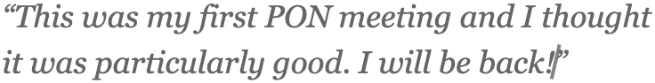
This planning session included twenty people from diverse sectors and areas of Scotland (mostly central belt).

We asked, given the recovery, recruitment and economic challenges, and emerging National Care Service (NCS), where should the PON put its energies and how to make best use of all of our resources? (Bearing in mind our small budget – 0.2 of a facilitator and a few face-to-face events).

Session 1
In groups we discussed hopes for the day, challenges we’ve experienced to an outcomes-approach and what the PON can help with some of these over the next year. Below are some of the themes:

Hopes for the day
- (Re)connect with like-minded people / peer support
- Conversations, ideas & inspiration
- Get back to basics / recapture skills that easily get lost
- Learn about other roles and services
- Take learning back to my colleagues
- Share good practice and resources
- Hope to get shared sense of purpose
- Getting clear on priorities for the PON
- Hear more about Personal Outcomes Network

Challenges with personal outcomes

Outcome focused conversations
- Need guidance to prepare people to engage in PO conversation
- Having the time for outcome-focused conversations
- Still too much focus on deficits and disabilities in systems

Recording and evidencing outcomes
- Confidence in recording and presenting outcomes
- Box ticking still predominates
- Too many / too different tools
- How to shape ways of working with limited IT tools/system
- How capture outcomes not being achieved (hidden)
- Difficulty in capturing / evidencing long-term indirect benefit
- Systems/commissioning/performance tend to be focused on quantitative data & outputs

Understanding outcomes and a whole system approach
- Ensure outcomes for people are not overshadowed by system outcomes
- Need greater consistency across partners / agencies around outcomes
- Need to build culture, systems and practice around outcomes within organisations
- Need to build understanding of outcomes at each level including middle management
- Need easily accessible evidence about the benefits of working this way
- Need better understanding of the Carers Act across sectors

What can the PON do?

Importance of providing a safe space for learning and exchange
- Permission to be honest and open about challenges
- The fact that there is a network is a positive in itself
- Celebrate small steps forward and successes
- Asking what matters is a form of choice and control – we need to model that
- Help model and share learning about how to win hearts and minds to shift culture

Supporting understanding outcomes and a whole system approach
- Can PON foster champions in each local (HSCP) area?
- Can the PON work with others to provide e-learning (potential to join forces with Wales)?
- Promote experiential learning opportunities and reflective practice sessions?
- Can the PON actively support teams? Eg project work and tests of change?
- Consider how PON can support reduction in health inequalities
- Focus on promoting understanding at management, finance and commissioner level
- Promote best practice in using lived experience / stories
- See a shift towards outcome-focused recording from Scottish Gov.

Session formats, locations
- Strong agreement across all three tables for a mix of online and face-to-face meetings
- The purpose/content could vary; e.g. face to face more cultural and online more practical
- Online half-day sessions could potentially follow face-to-face sessions
- Full-day (face-to-face) sessions could be divided into two
- Mornings focus on inputs and afternoons for further exploration and networking
- The Golden Jubilee has been a great venue but need more accessible venues too
- Members could propose their premises and could pay modest fee from PON budget
- There was very strong support for an overnight event over two days!

Contact in between sessions
- How can members stay in touch with each other in between sessions/share learning?
- A WhatsApp Group is easy to set up, and facilitates quick responses
- Not everyone has a work phone so this encroaches into personal time
- PDF profiles on PON website – could include a photo, profile information and areas of focus
- This would require monitoring to keep it up to date
- MS Teams Channel can usually be used at work/on work devices
- This also may not be open to everyone

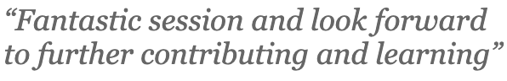
Session 2
This session focused on gathering views on the themes people are keen to see the PON focus on in the next year and thoughts on membership.

What themes would you like to see at future PON events?
- Commissioning
- Eligibility Criteria Project (already committed to this)
- Recording including capturing outcomes in short interventions
- Support and supervision for staff
- Support to carers and continuing implementation of the Carers Act
- A Back to Basics of the approach – could be online
- Using stories/qualitative and quantitative data

Underpinning themes / approach to sessions
- Hearing about member projects/developments – “show and tell”
- Staff wellbeing – promoting mentally healthy workplaces
- Continue to recognise and acknowledge trauma of pandemic
- Take a holistic approach to cover culture, systems and processes.

Membership
- Representation of sectors and the diversity of members attending varies over time
- Who attends is also influenced by the theme of the session
- Need to consider consistent diversity of members attending by active engagement
- Engage our neurodivergent members in ensuring our sessions are run appropriately

Final comments
Thanks to everyone who came. We all agreed how good it was to be face-to-face again but also the benefits of maintaining online engagement too. The co-ordinating group got lots of inspiration and ideas to help us plan sessions and content that meet the needs & interests of the network. We’re really looking forward to working together over the next year! We have designed a survey so that we can get the views of the wider membership.

