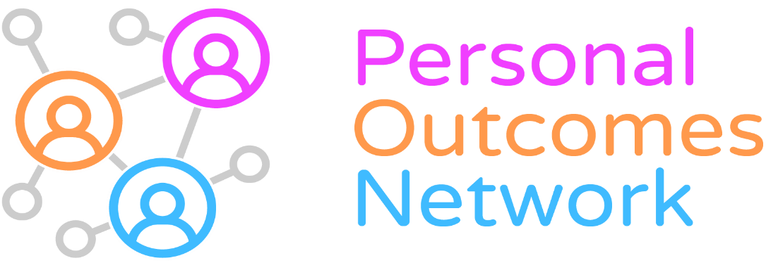

Using Stories in Services: Brief Report and resources following PON Workshop: 7th July 2021, 10.00 to 12.00

A: We had two great presentations from our guest speakers:
- Nick Andrews, Swansea University: Magic and Tragic Moments. Ideas and Methods for storytelling
We need to be attentive and respond to the individual story / experience rather than rigidly sticking to protocols and procedures even when they might be causing unintentional harm

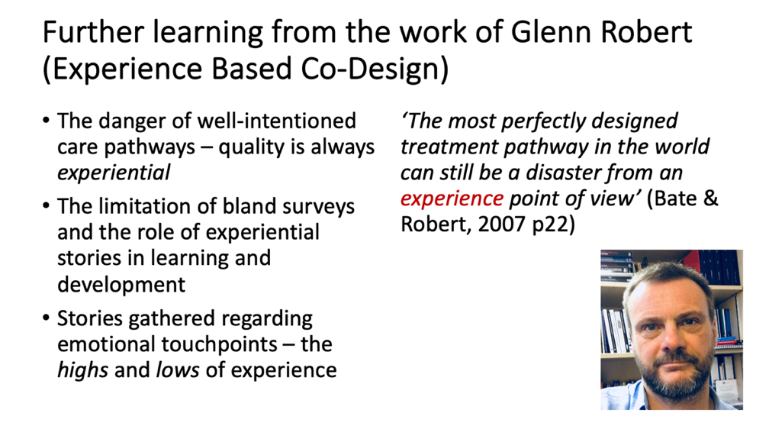

Often the human wisdom that promotes wellbeing is not in the job description or indicators but is what really matters – captured by the concept of ‘undercover kindness’ in this slide:

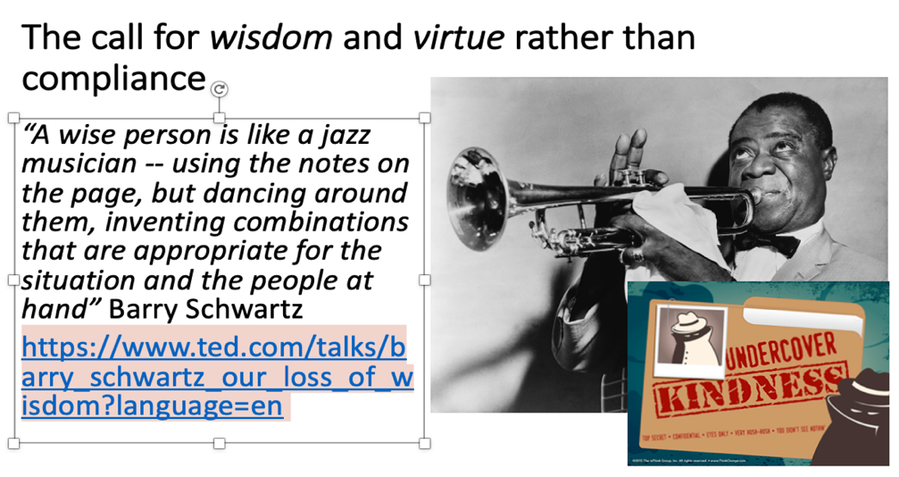
- Tim Chapman, European Forum for Restorative Justice: Narrative dialogue: Using stories to navigate difficult conversations
Both Tim and Nick, coincidentally, included jazz analogies in their presentations.

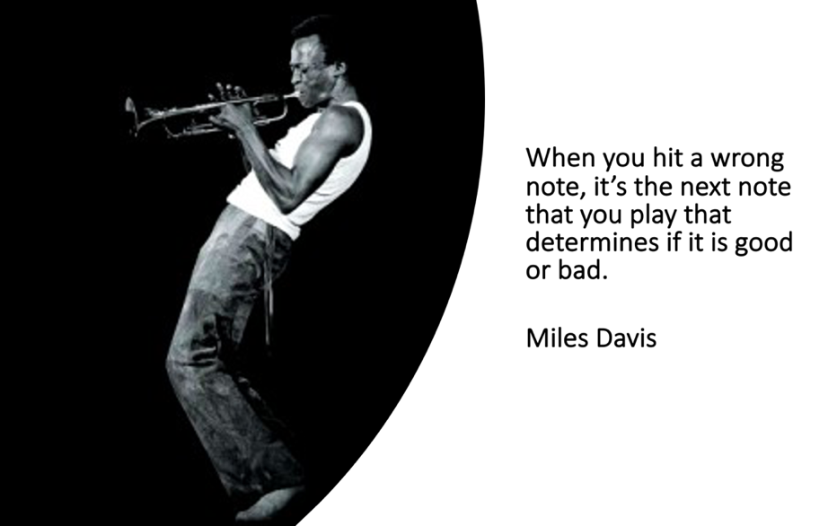

Tim talked about the need to show humility in stepping into people’s lives, remembering that we only play a small part in their story. He included a draft structure he is working on to support listening and responding to truths in the context of restorative practice:

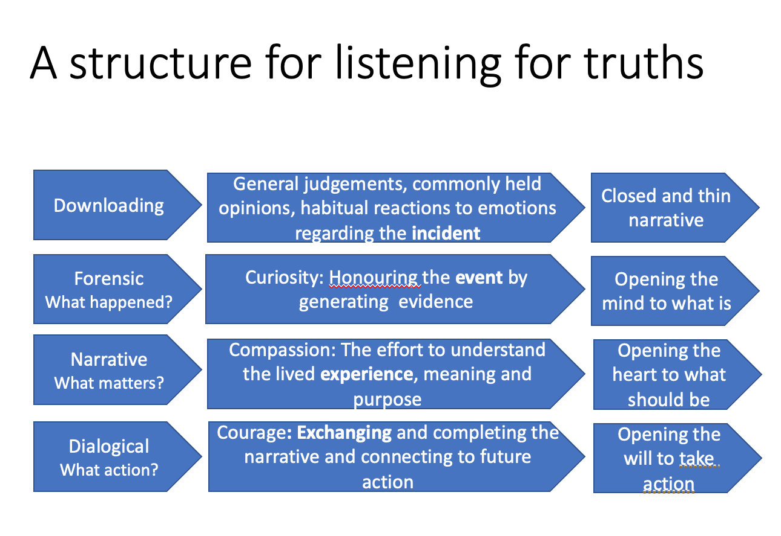

B: Some key reflection points from the discussions

Who do you ask to tell the story? How do you avoid leading the conversation?

Have we given any thought to our own story? That’s worth thinking about too

Staff stories should be part of the overall story – they bring knowledge and experience of where the beartraps lie in services – we all need to know where those traps lie

Challenge for how stories are received – defensiveness – how to get past that type of response – “that should not have happened”

How do you respond to the emotions that arise for people when they tell their story?

There is a value in capturing stories at different points – like with the PON COVID stories project – what matters, what works, changes over time

There were different views about the skill involved in facilitating story telling. Is it a separate skill set that requires training and development? Is it an innate skill set that needs space and time to do it well?

How do we avoid prescriptive tools overshadowing the opportunity for conversation? And twisting the story to fit a corporate or service need?

Stories probably most useful if elicited by the person providing 'the service' in the flow of the work, not a separate external exercise....and they are viewed as a process not an event.

Tim is working on a format to keep a record of restorative conversations, to include:
- What happened/happening – the facts
- What’s the emotional impact
- What really matters about what’s happened/happening
- What do you want other people to understand
- What do you want to know/understand about the other person/people’s perspective
- What do you want
- How will you do that
C: Some resources shared by participants

A 2020 Catalyst For Change project co-produced a story based resource to help community nurses cope with secondary psychological trauma at work.

https://www.qnis.org.uk/catalysts-for-change-seeds-project/

Human Learning Systems: A Complexity Friendly Approach to Public Services

https://www.centreforpublicimpact.org/​

Sway report on stories and quality improvement https://sway.office.com/2dtQpdpZsQ9eK82L?ref=Link

Learning from experience-based co-design

https://ihub.scot/improvement-programmes/evidence-and-evaluation-for-improvement/summaries-of-evaluation-work/learning-from-experience-based-co-design-demonstrator-sites/

Journal article: Appreciative dialogue for co-facilitation in action research and practice development

https://www.fons.org/Resources/Documents/Journal/Vol3No2/IPDJ_0302_07.pdf

Journal article: Moving stories: exploring the LIFE session storytelling method as a way of enhancing innovative, generative outcomes in practice

https://www.fons.org/library/journal/volume11-issue1/article6

Personal Outcomes Network stories page including link to our covid stories project:

https://personaloutcomes.network/stories/

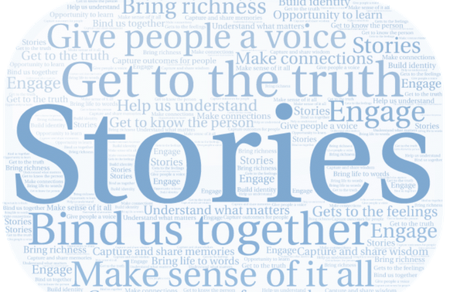

Personal Outcomes Network – a reminder of what our members told us they value about stories (from February 2021 workshop)

D: Further information and links about the Personal Outcomes Network

See: https://personaloutcomes.network/

Please contact: PON@nes.scot.nhs.uk

Follow: @personaloutcom1

